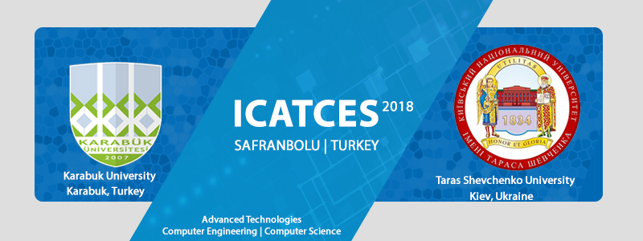
Dear Colleagues,
On behalf of the organizing committee, we are pleased to announce that the International Conference on Advanced Technologies, Computer Engineering and Science (ICATCES18) will be held from May 11 to 13, 2018 in Safranbolu, Turkey. ICATCES18 is an opportunity for academics, researchers and industrial practitioners to share their ideas and experiences from around the world who are involved in the Computer Engineering, Computer Science and Advanced Technologies. Authors are invited to submit their original unpublished manuscripts reporting recent developments in Computer Science, Computer Engineering and Advanced Technologies to ICATCES18.

All publications will be published in the proceedings book. Also, selected papers from ICATCES18, after further revisions, will be published in JESTECH - Engineering Science and Technology, an International Journal (Elsevier,ESCI). Best Paper Awards and Best Student Paper Awards will be conferred at the conference (in order to qualify for the award, the paper must be presented at the conference).

The language of the symposium will be English. In addition to our conference scientific sessions, we would like to invite you to visit UNESCO World Heritage City Safranbolu, Turkey. The details of symposium scope can be found in the symposium website. We hope to see you in ICASTES18 Safranbolu/Turkey.
Organizers: Karabuk University (Turkey) and Taras Shevchenko National University of Kyiv (Ukraine)
Important Dates
- Abstract submission: 28 February 2018
- Notification acceptance for abstract: 09 March 2018
- Full paper submission: 30 March 2018
- Notification acceptance for full paper: 13 April 2018
- Announcement program schedule: 2 May 2018
- Symposium Dates: 11-13 May 2018
Please forward this e-mail to your colleagues and potential authors who might be interested in contact: icatces2018@karabuk.edu.tr
All submissions will be peer-reviewed based on originality, technical quality and presentation.
Click here to submit your paper
Best Regards.
Assoc.Prof.Dr. Oğuz FINDIK
Symposium Chair

